Nepal College of Information Technology

**Unit Test**

Spring 2012

Program : CE/ELX Time : 2 hrs

Semester : (II) FM : 70

Subject : Applied Mechanics PM : 35

* *Candidates are requested to give their answer as far as practicable in their own words.*
* *The figure in the margin indicates the full marks*
* ***Attempt ALL question***

1. a) What is applied mechanics? Define the term free body diagram with suitable examples. What are the guidelines to be considered while drawing a free body diagram? **(2+3+3)**

b)A system of forces acting on a lever is as shown in figure. Determine the magnitude, direction and position of resultant. (8)

1000N 1200N 3000N 1500N 800N

600  450

A B C D E

2m 4m 3m 1.5m

1. Three cables are connected at A, where the forces P and Q are applied as shown. Knowing that **P** = 1200 N, determine the range of values of Q for which cable AD is taut. **(15)**



**OR**

A Transmission tower is held by three guy wire attached to a pin at A(given in fig.) and anchored by bolts at B, C and D Knowing that the tower exerts on the pin at A an upward vertical force of 1500N, Determine the tension in each wire. **(15)**

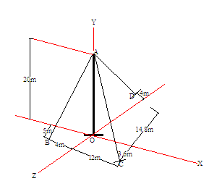

3. a) Define couple.Mentoin the characterstics of Couple.Derive a relation for the moment of force about a point. (8)

b) Determine the magnitude and the direction of the resultant of three forces as shown.(7)

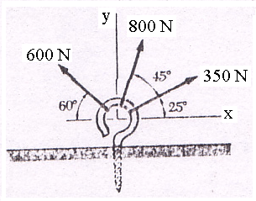

4. a) What are the principles of the equilibrium of the body? What are the equations of equilibrium?why equlilibriun is essence in structural application?. (7)

b) The cylinders A and B weighting 1000 N and 2000N. It is given that radius of A is 0.60m and radius of B is 1.2m. Determine the forces exerted at the contact points. (8)



5. **Write short notes on.(any two)**  (5*2=10)

a) Fundamental principles of applied mechanics

b) Varignon theorem

C) Difference between centroid and Centre of Gravity

d) Resolution of Force